An IPv4 address is 32 bits long. IPv4 addresses are unique and universal.

There are two notations to show an IPv4 address: binary notation and dotted-decimal notation.

1) Binary Notation:

The IPv4 address is denoted as 4 sets of 8 bits (4-byte address) each. Ex :

01110101 10010101 00011101 00000010

2) Dotted-Decimal Notation:

To make the IPv4 address more compact and easier to read, Internet addresses are usually written in decimal form with a decimal point (dot) separating the bytes. The following is the dotted-decimal notation of the above address:

117.149.29.2

Each number in dotted-decimal notation ranges from 0 to 255.

CLASSFUL ADDRESSING:

1. CLASSES :

In classful addressing, the address space is divided into five classes: A, B, C, D, and E.

The IP address in class A, B, or C is divided into netid and hostid. Figure 19.2 shows some netid and hostid bytes. The netid is in yellow color, the hostid is in white.

In class A, 1 byte defines the netid and 3 bytes define the hostid. In class B, 2 bytes define the netid and 2 bytes define the hostid. In class C, 3 bytes define the netid and 1 byte defines the hostid. Note that the concept does not apply to classes D and E.

We can find the class of an address :

1) If the address is given in binary notation, the first few bits tell the class of the address.

2) If the address is given in decimal-dotted notn., the first byte tells the class.

Figure 19.2

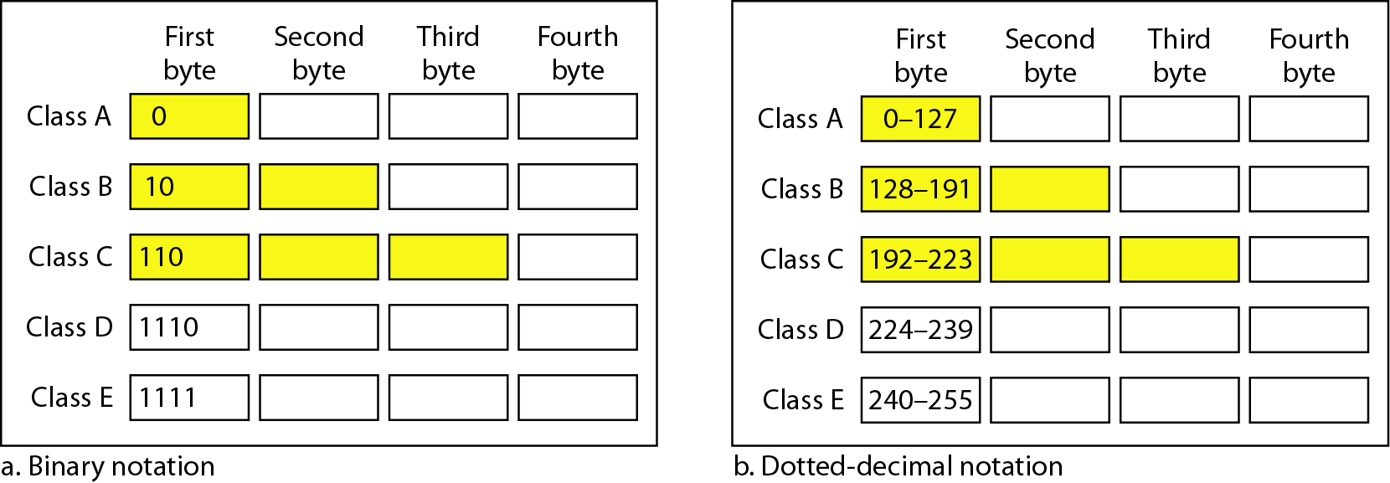

1. BLOCKS :

Each class is divided into a fixed number of blocks; which have a fixed size.

1. MASK :

Mask is a 32-bit number made up of contiguous n no. of 1s followed by contiguous 32-n no. of 0s. Mask /n means the n leftmost bits in the mask are 1s and the 32 - n rightmost bits are 0s

In classful addressing, the default mask (n) can be 8, 16, or 24 for class A, B,C respectively. The concept does not apply to classes D and E.

In classless addressing, the mask (n) for a block can take any value from 0 to 32. It is convenient to write the mask as ‘/n’ (CIDR or slash notation). Classless Interdomain Routing (CIDR) notation is used in classless addressing

Each class has a default mask.

Table 19.2 Default masks for classful addressing



CLASSLESS ADDRESSING:

BLOCKS :

1) There are no classes, but the addresses are still granted in blocks. A block of addresses can be defined as x.y.z.t /*n*

x.y.z.t defines one of the addresses and /*n* defines the mask.

2) Restrictions on classless address blocks:

There are three restrictions on classless address blocks:

1. The addresses in a block must be contiguous, one after another.

2. The number of addresses in a block must be a power of 2 (I,2,4,8,..).

3. The first address in the block must be evenly divisible by the number of addresses.

3)

* First Address :The first address in the block can be found by setting the 32 - n rightmost bits in the binary notation of the address to 0's.
* Last Address : The last address in the block can be found by setting the 32 - n rightmost bits in the binary notation of the address to 1's.
* Number of Addresses : The number of addresses in the block is can be found using the formula 232-n.

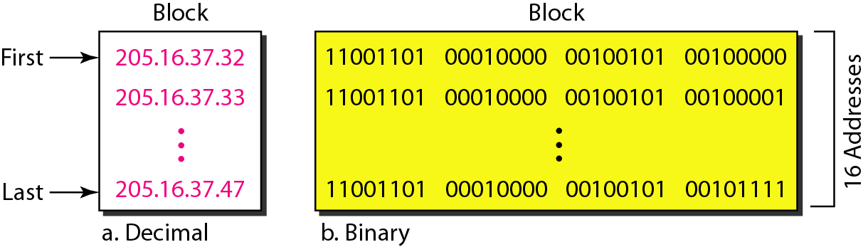

Figure 19.3 A block of 16 addresses granted to a small organization

MASK :

In classless addressing, the mask (n) for a block can take any value from 0 to 32. Mask /n means the n leftmost bits in the mask are 1s and the 32 - n rightmost bits are 0s.

It is convenient to write the mask as ‘/n’ (CIDR or slash notation). Classless Interdomain Routing (CIDR) notation is used in classless addressing.

SUBNETTING :

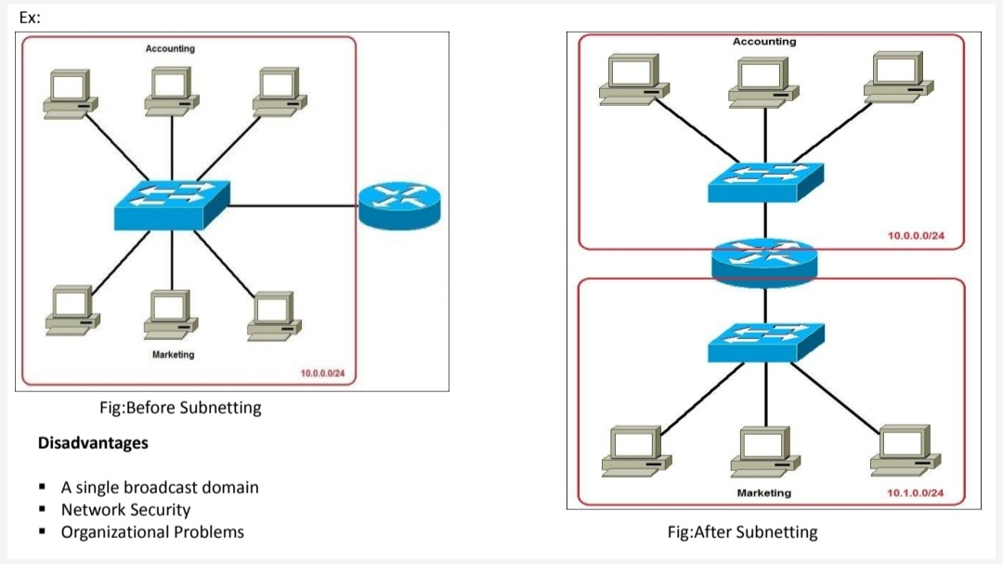

1. When we subnet a network, we basically split it into smaller networks (subnets ). This helps to reduce traffic and hides the complexity of the network.

2. The network has its own mask; each subnet also has its own mask.

3. Due to subnetting, the IP address has three levels of hierarchy :

* Network prefix,
* Subnet prefix (subnet mask) and

• Host address.

4. A subnet contains 2h addresses, where h is the number of host bits. (n=mask).

The first IP address in a subnet is the Network address for that subnet. The last IP address in the subnet is the Broadcast address for that subnet. The remaining IP addresses in the subnet can be used for hosts. So we subtract 2 from 2^h while finding number of hosts per subnet.

Number of network bits = n

Number of host bits h = 32 - n.

Number of hosts = 2h - 2.

Number of subnets bits = n - default mask for that class

Number of subnets = 2no. of subnet bits

Number of hosts per subnet = 2h - 2.

5. Example: Determine the number of Subnets and Hosts per subnets from the given IP address and Subnet mask.

IP address : 192.168.0.10

Subnet mask:255.255.255.224

